Database System Engineering and Distributed Backend Development
Course Code: 25CS13002E
ROLL NO:2520030032
NAME: A. AMULYA
INSERT CUSTOMER DATA
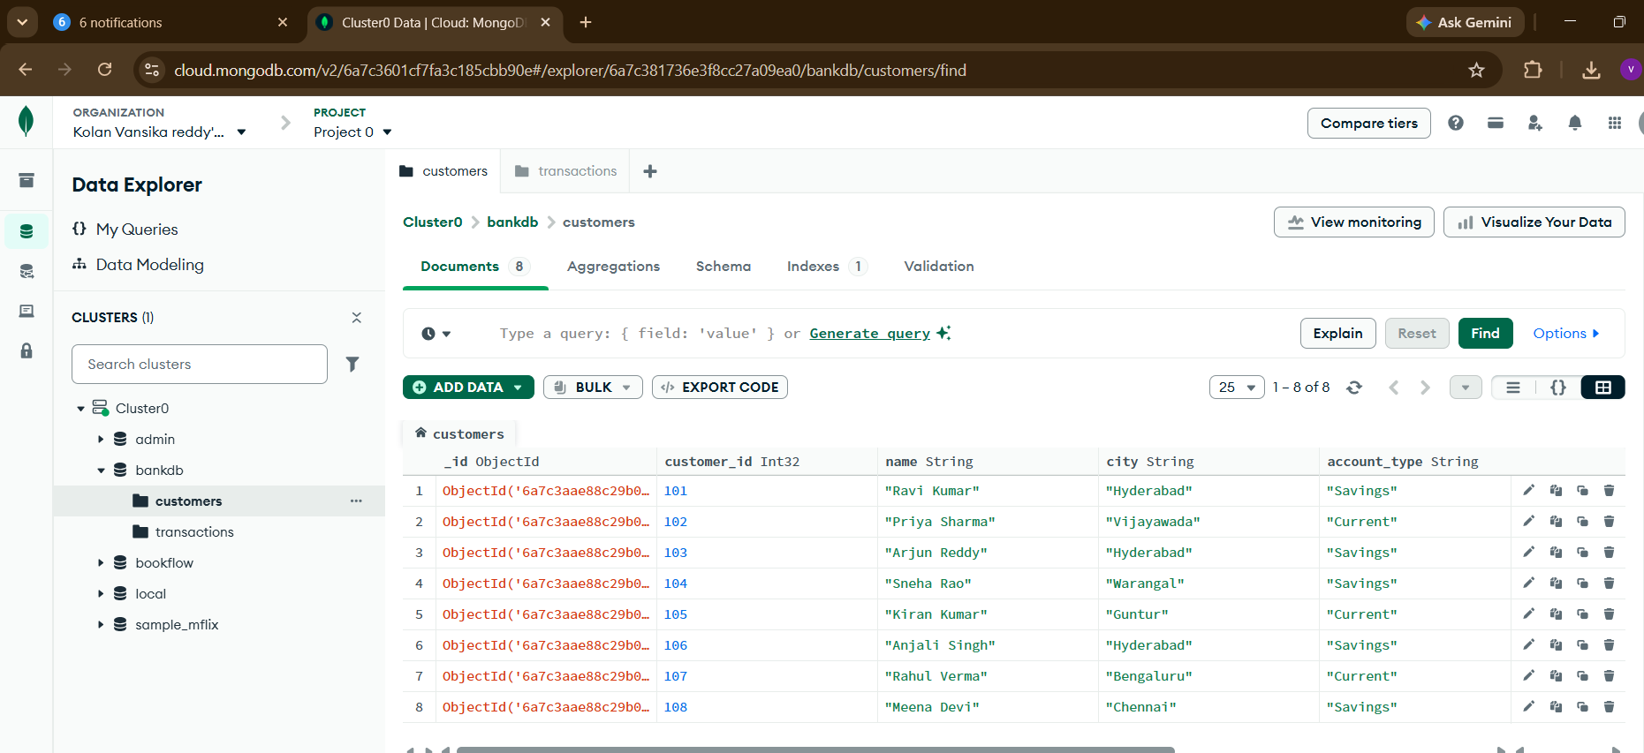
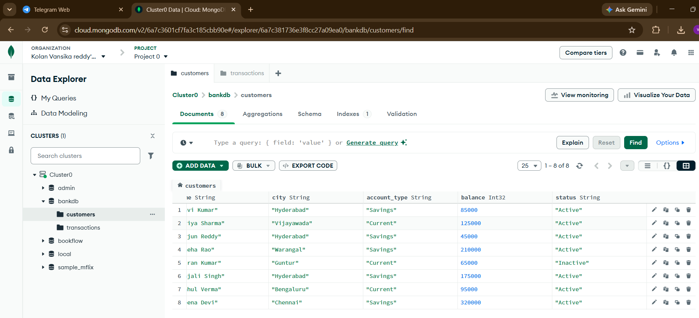

INSERT TRANSACTION DATA
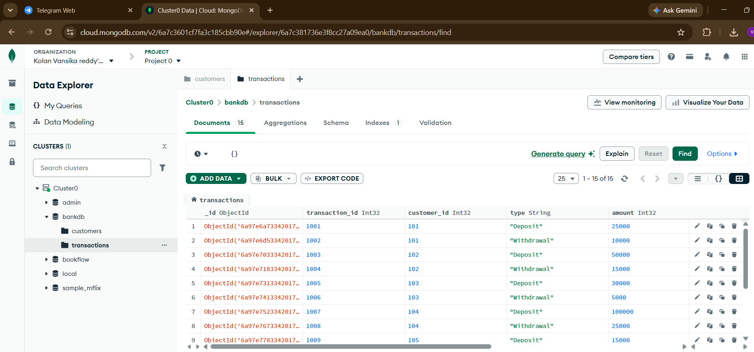
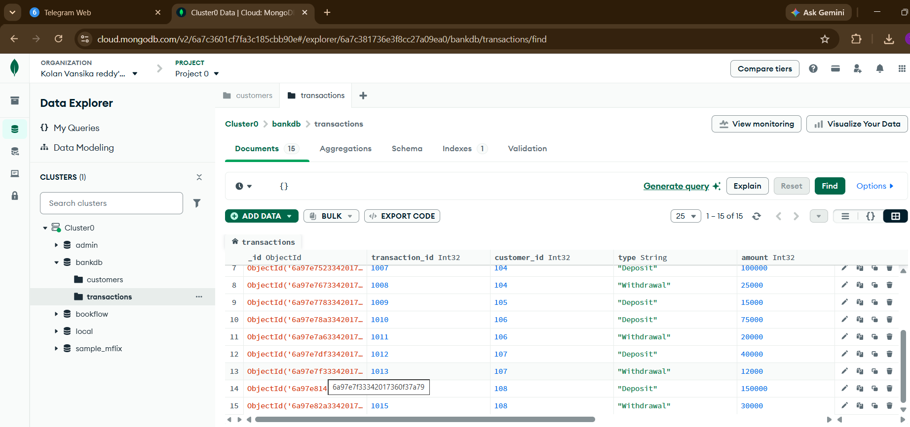
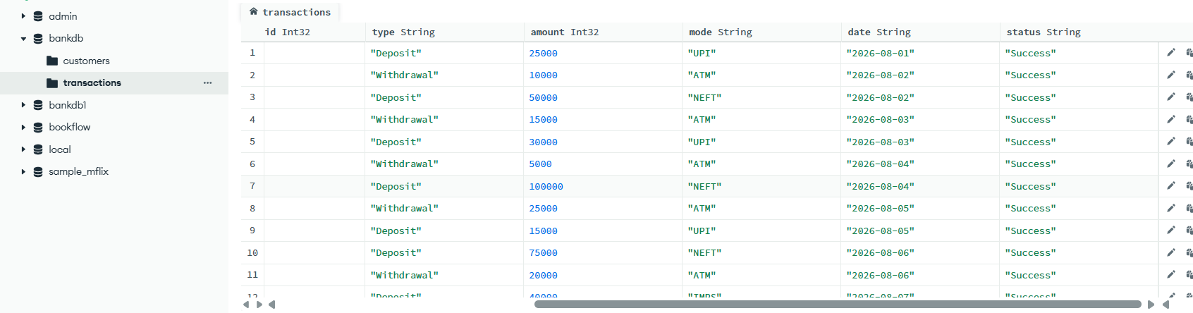

QUERY 1: DISPLAY ALL CUSTOMERS:
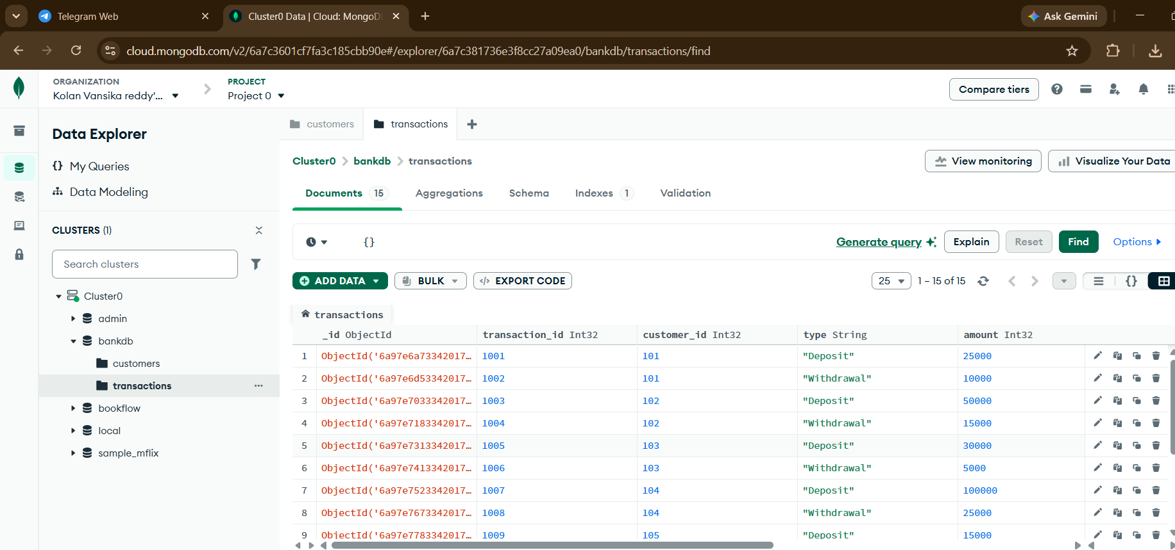

QUERY 2: FIND ACTIVE CUSTOMERS
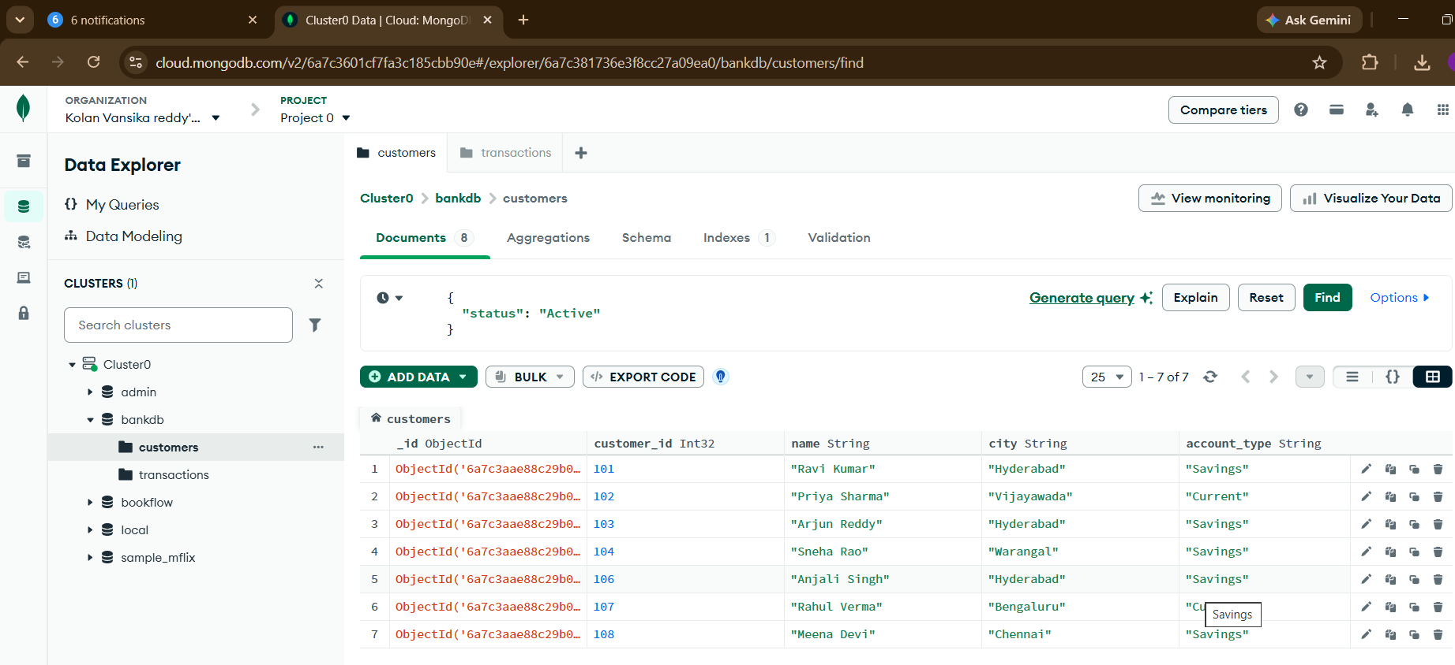
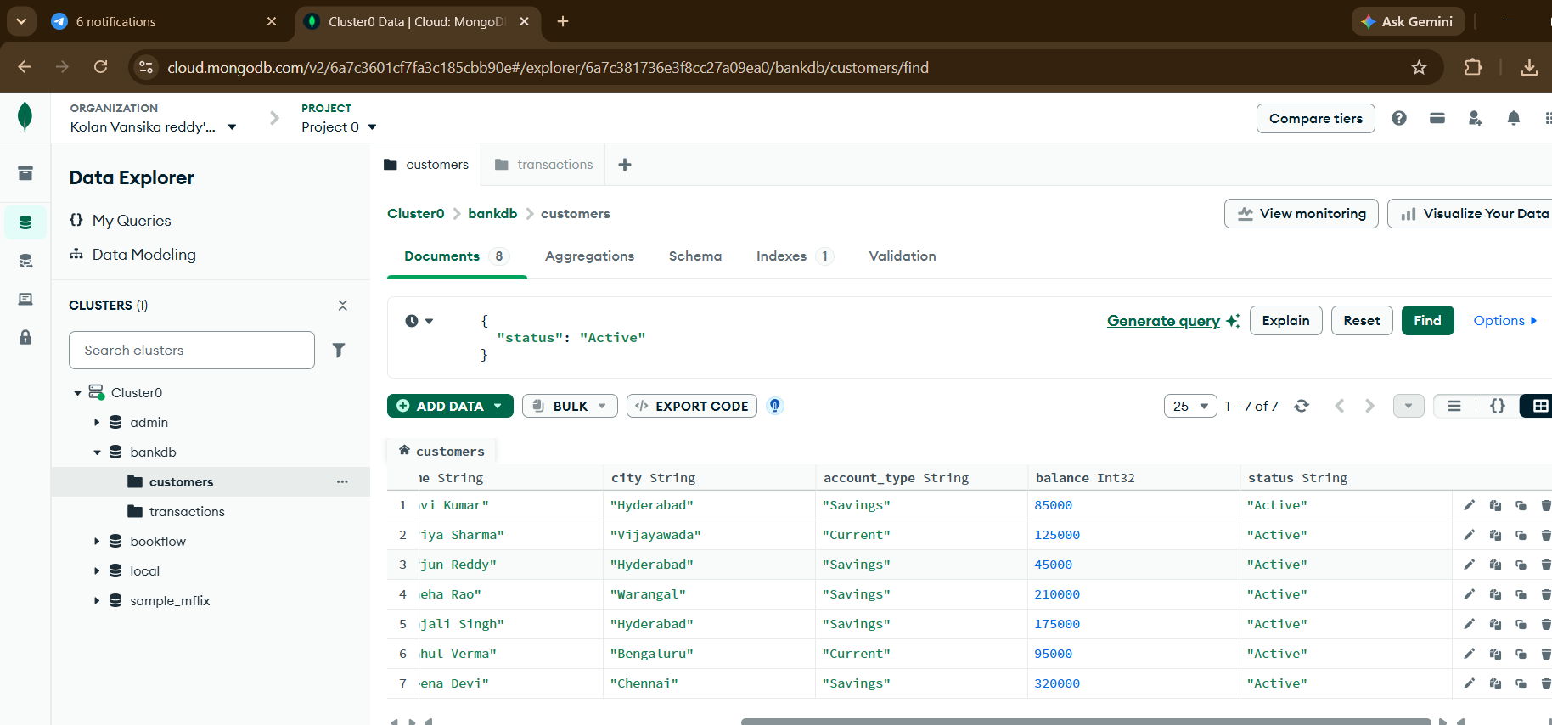

QUERY 3: FIND CUSTOMERS WITH BALANCE GREATER THAN 100000
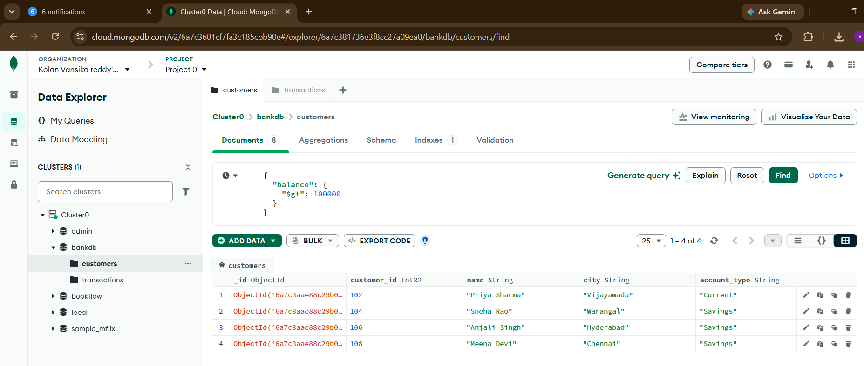

QUERY 4: FIND HYDERABAD CUSTOMERS:
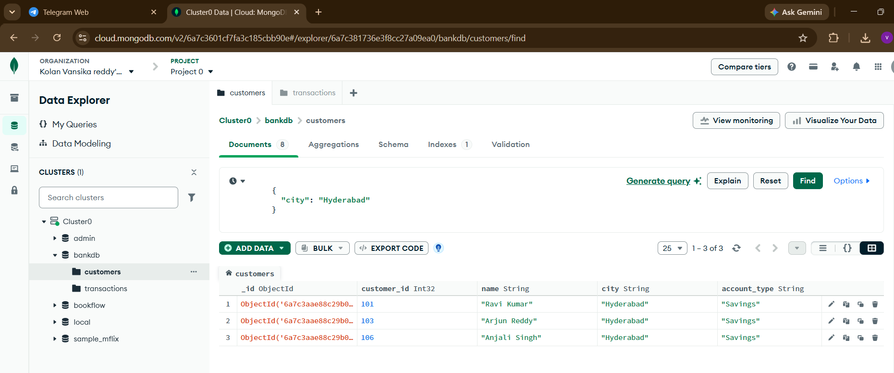

QUERY 5: FIND SAVINGS ACCOUNT CUSTOMERS:
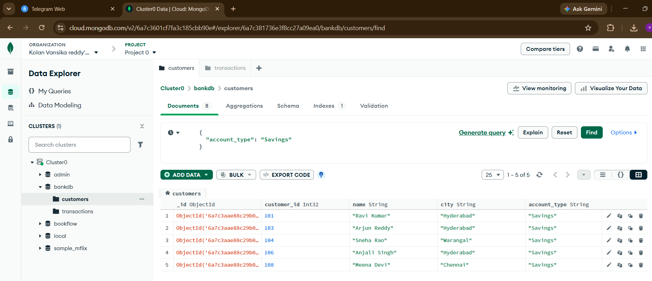

QUERY 6: FIND TRANSACTIONS GREATER THAN 20000:
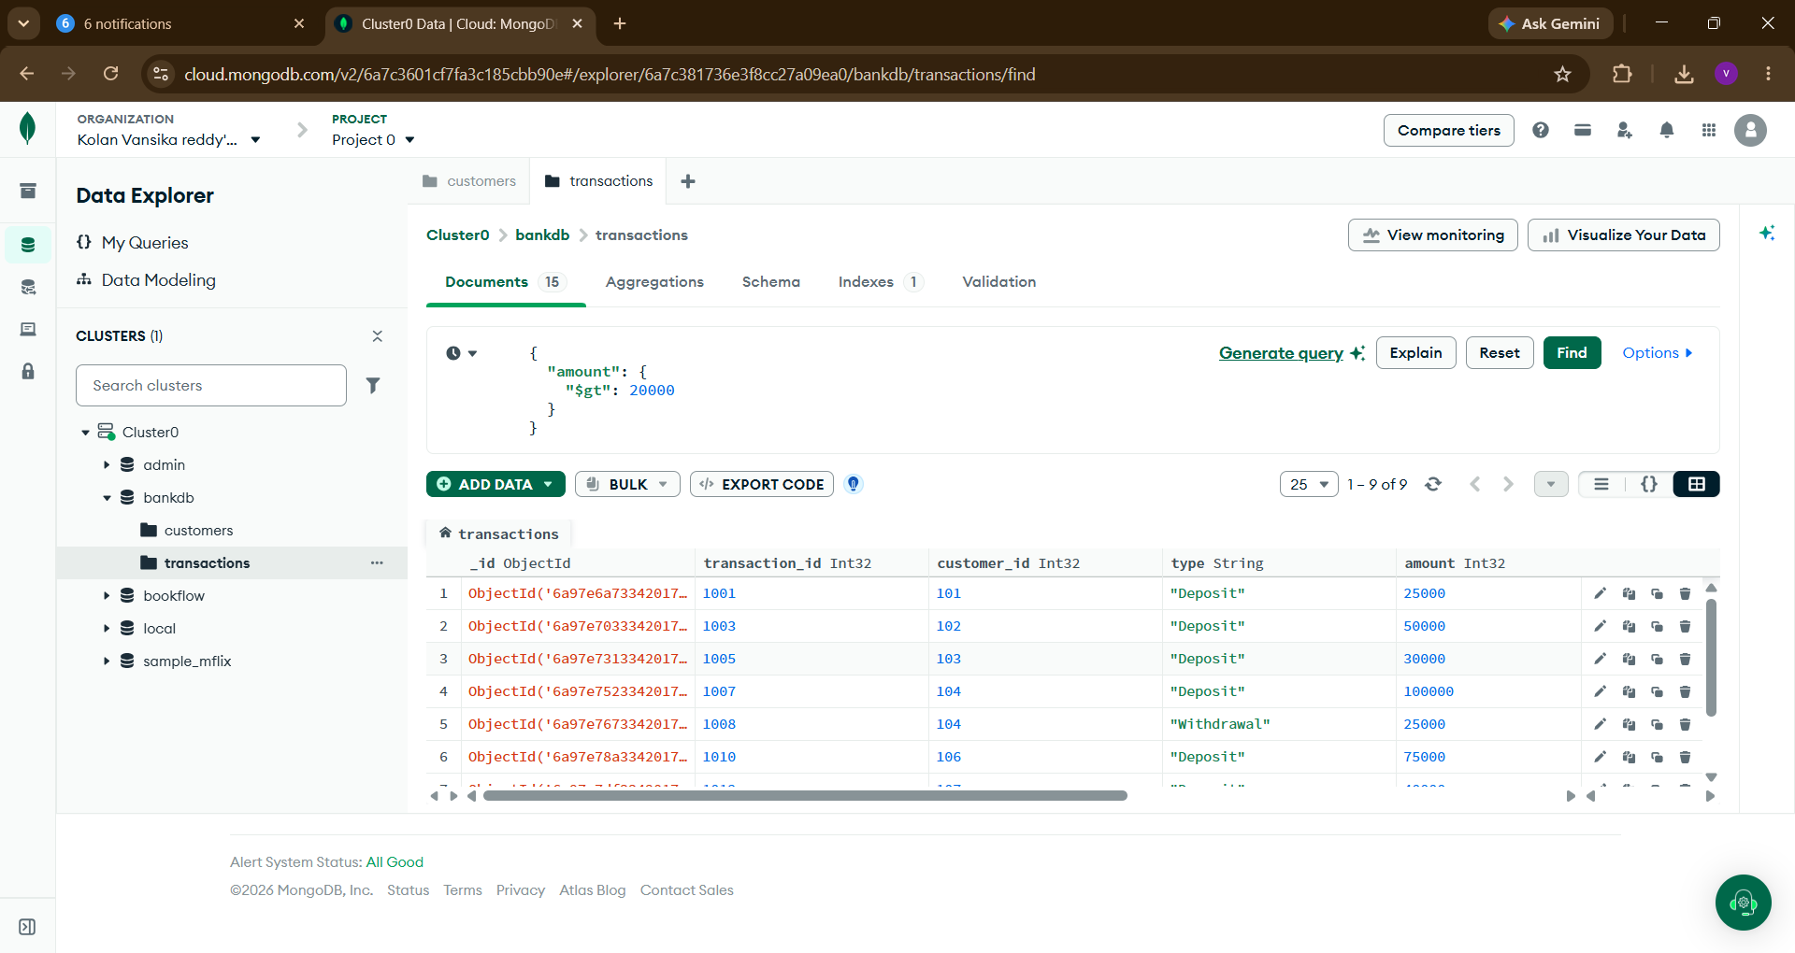

QUERY 7: FIND DEPOSITS
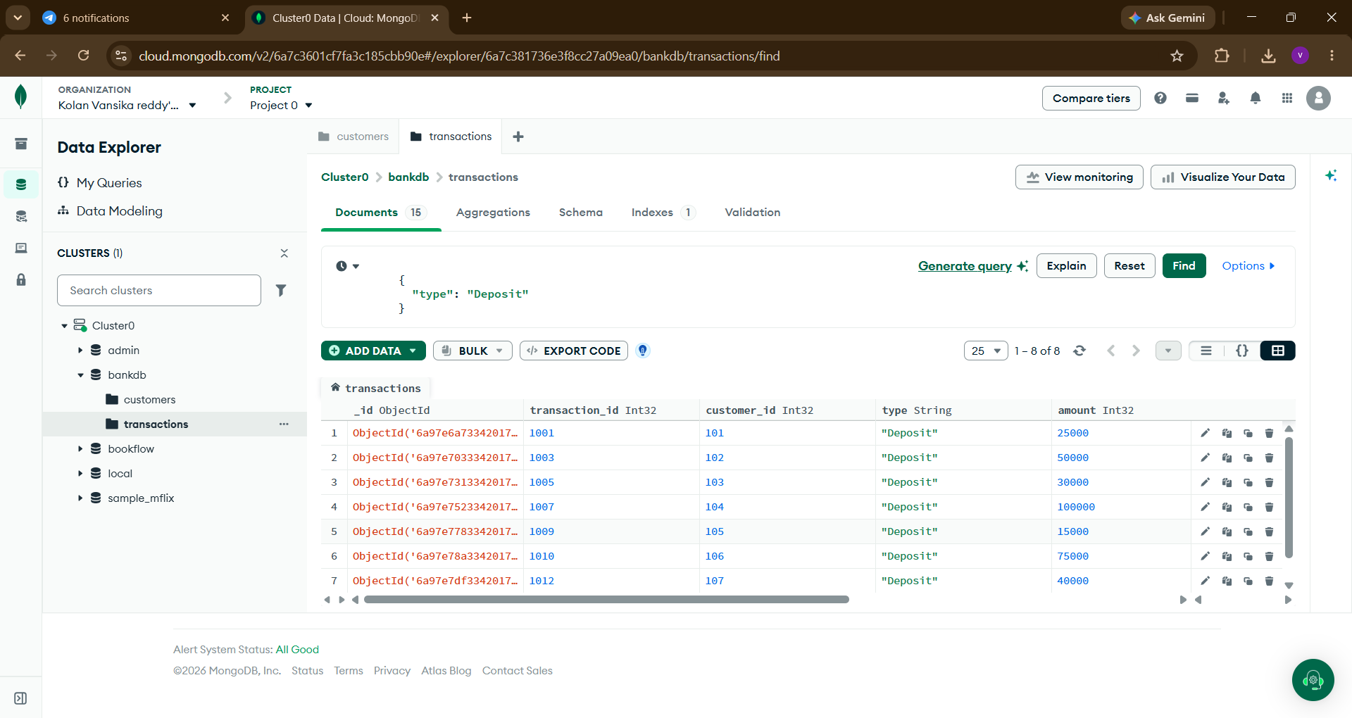

QUERY 8: FIND ATM TRANSACTIONS
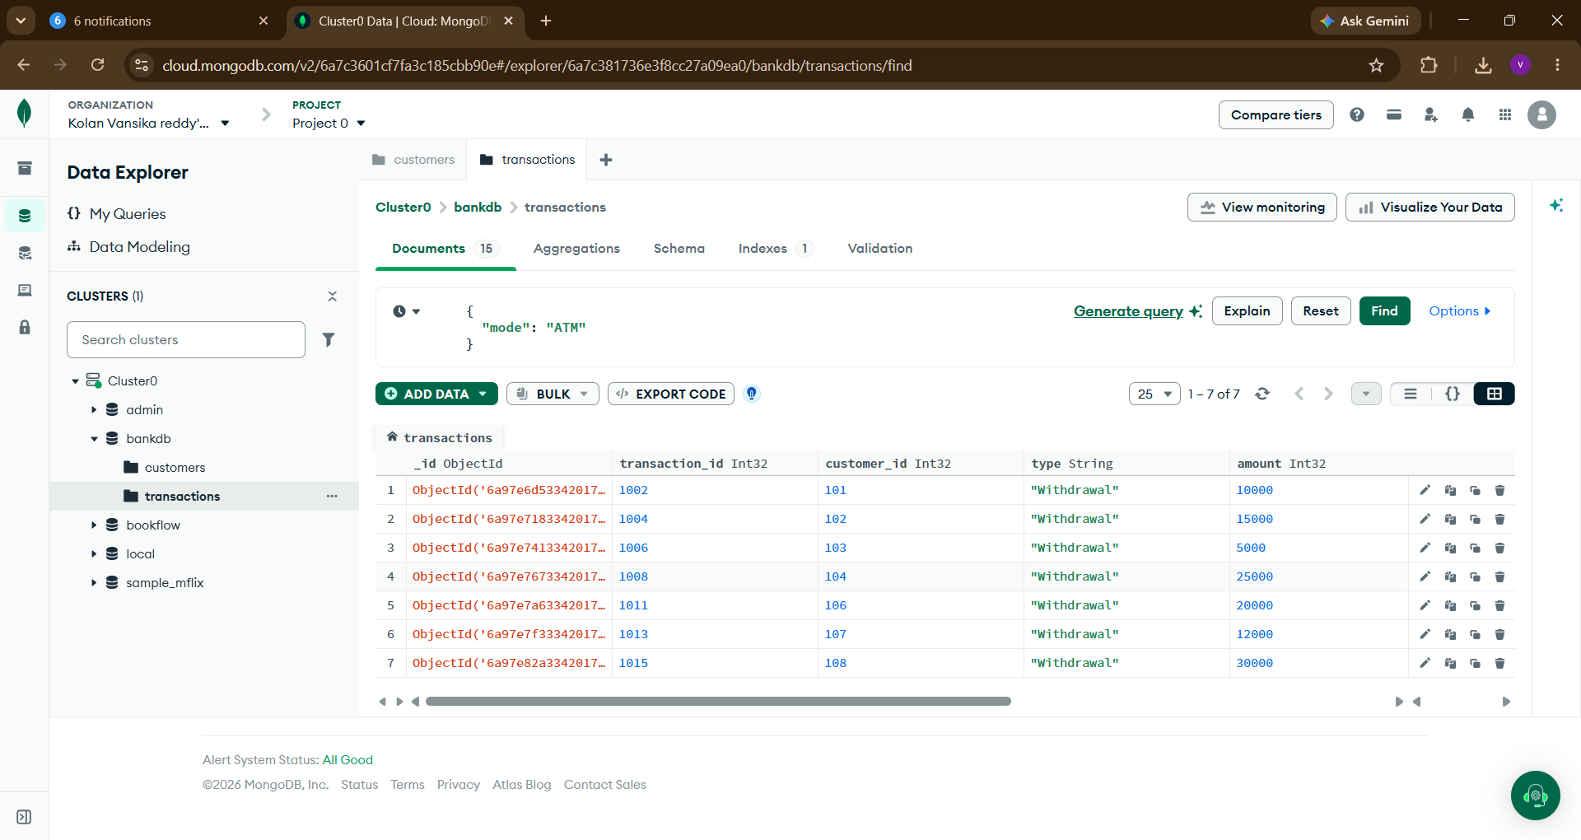

QUERY 9: FIND DEPOSITS GREATER THAN 50000
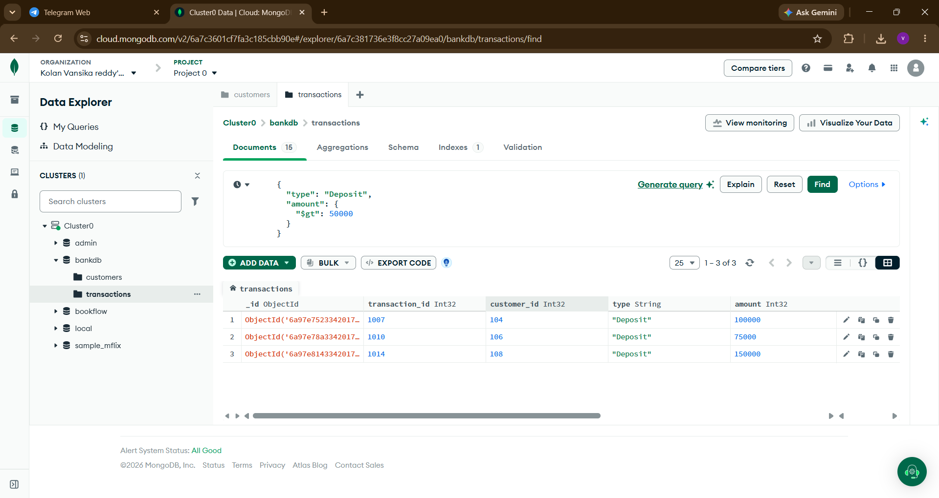

QUERY 10: FIND HYDERABAD CUSTOMERS WITH HIGH BALANCE
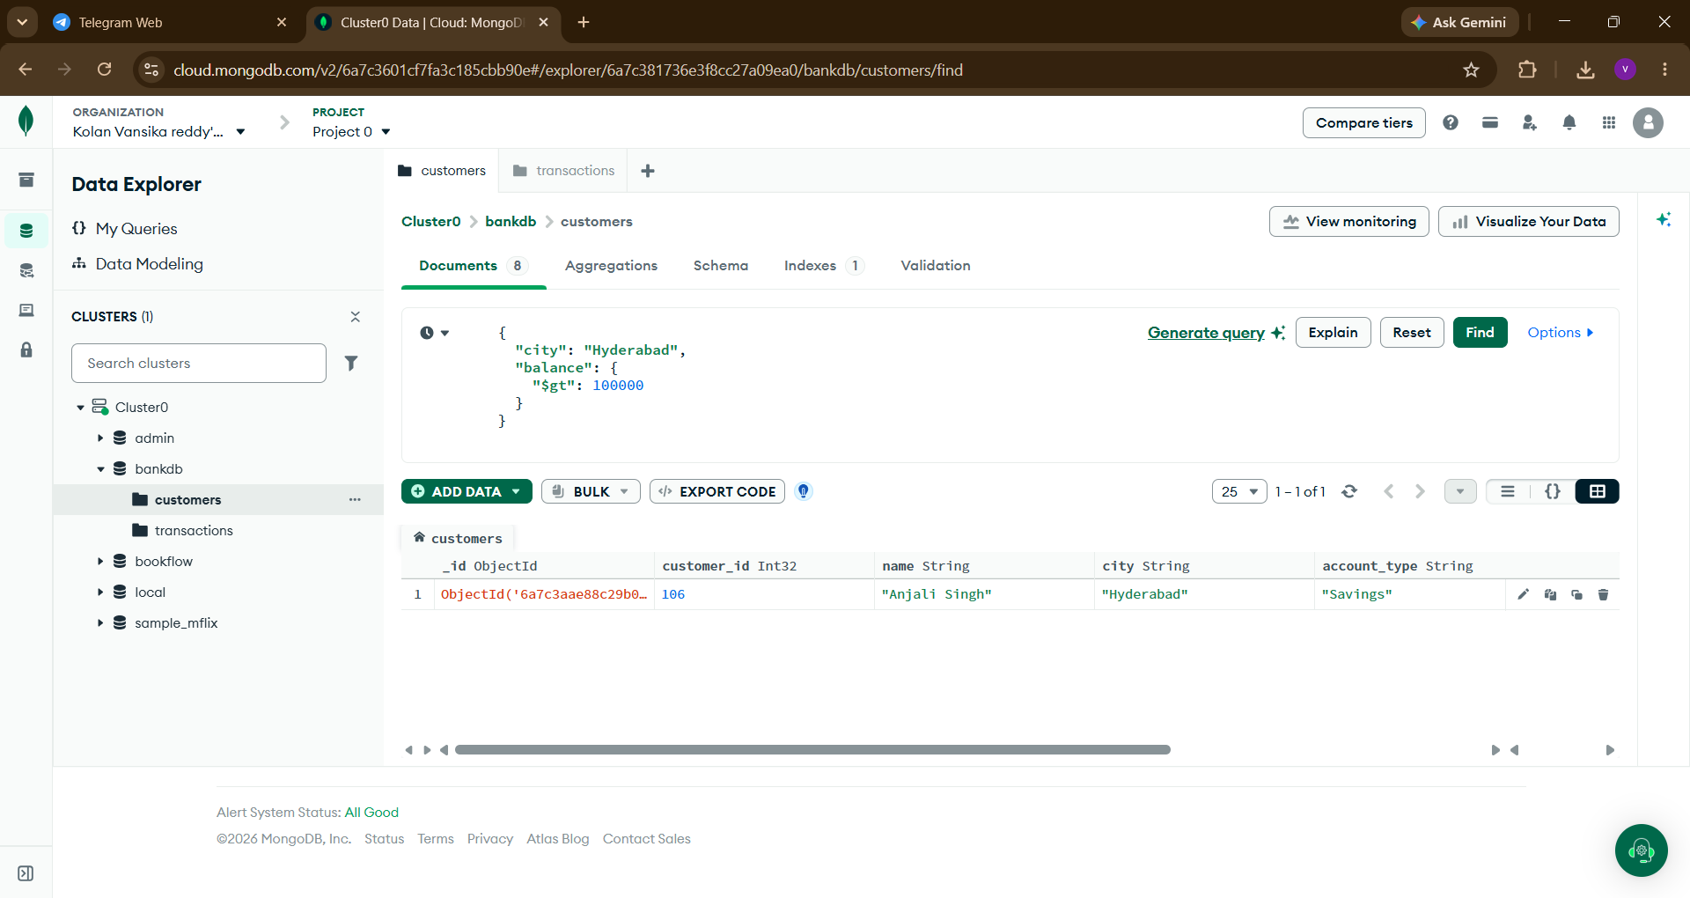

QUERY 11: FIND CUSTOMERS IN MULTIPLE CITIES
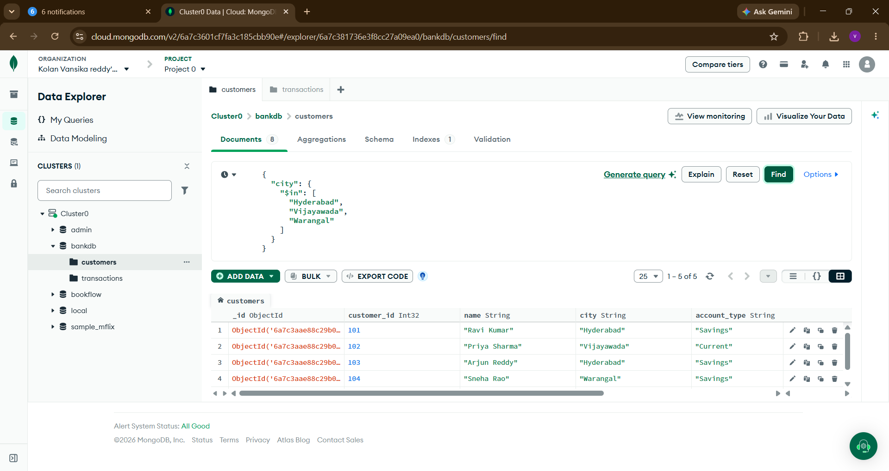

QUERY 12: SORT CUSTOMERS BY BALANCE
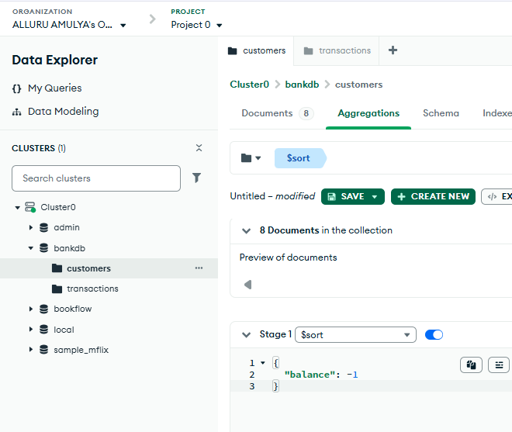
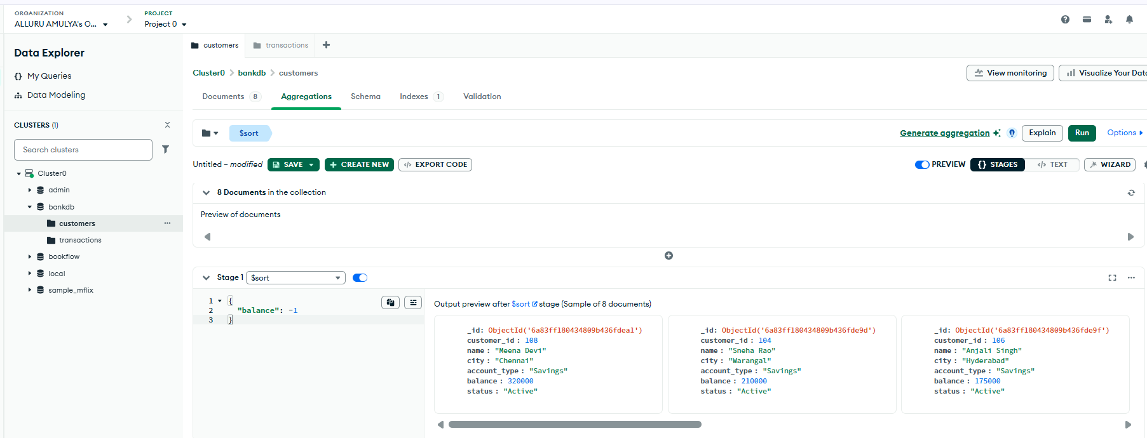
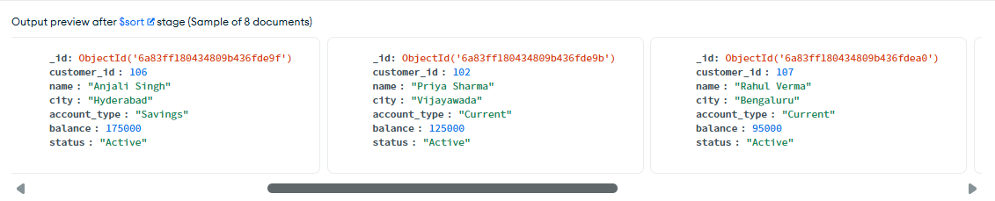
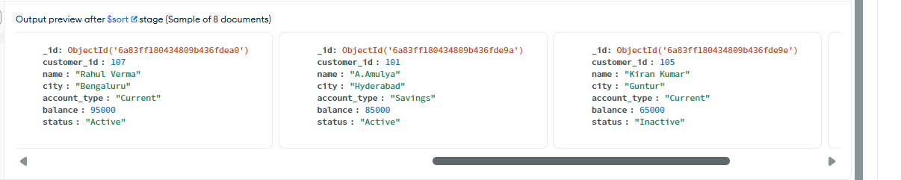
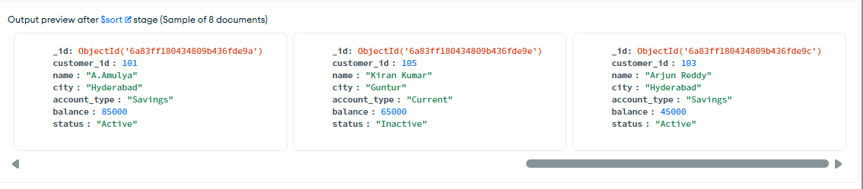

QUERY 13: CALCULATE TOTAL TRANSACTION AMOUNT
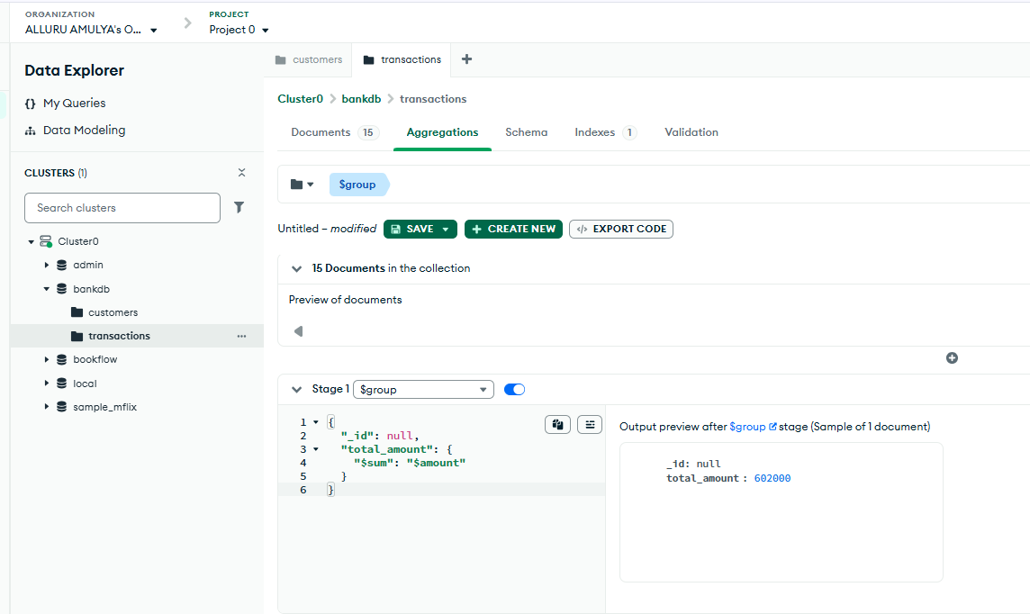

QUERY 14: CALCULATE AVERAGE TRANSACTION AMOUNT
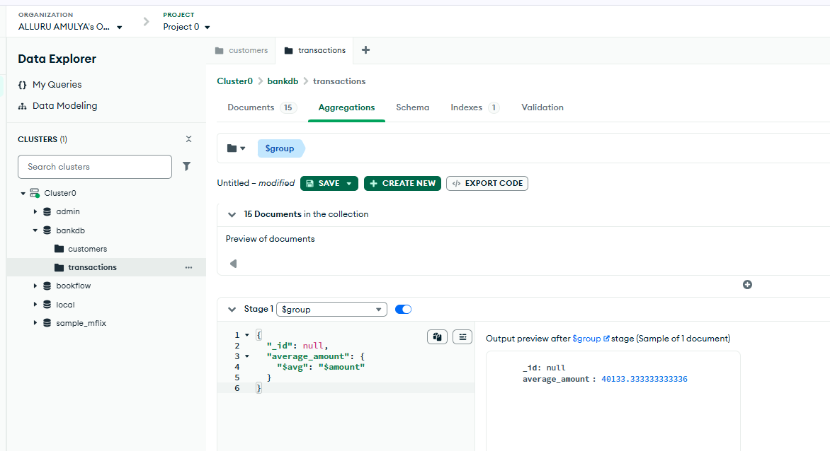

QUERY 15: TOTAL TRANSACTION AMOUNT BY TYPE
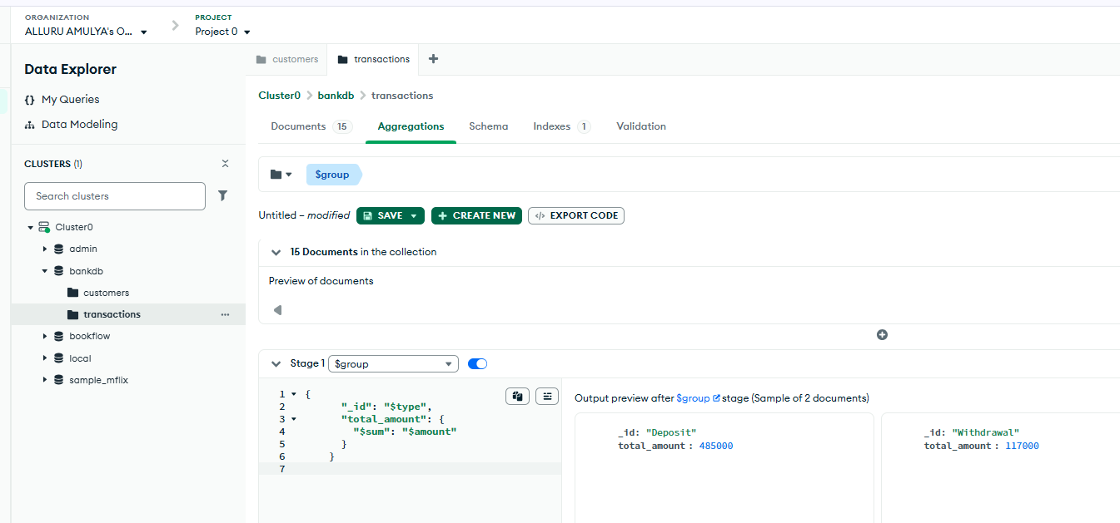

QUERY 16: NUMBER OF TRANSACTIONS PER CUSTOMER
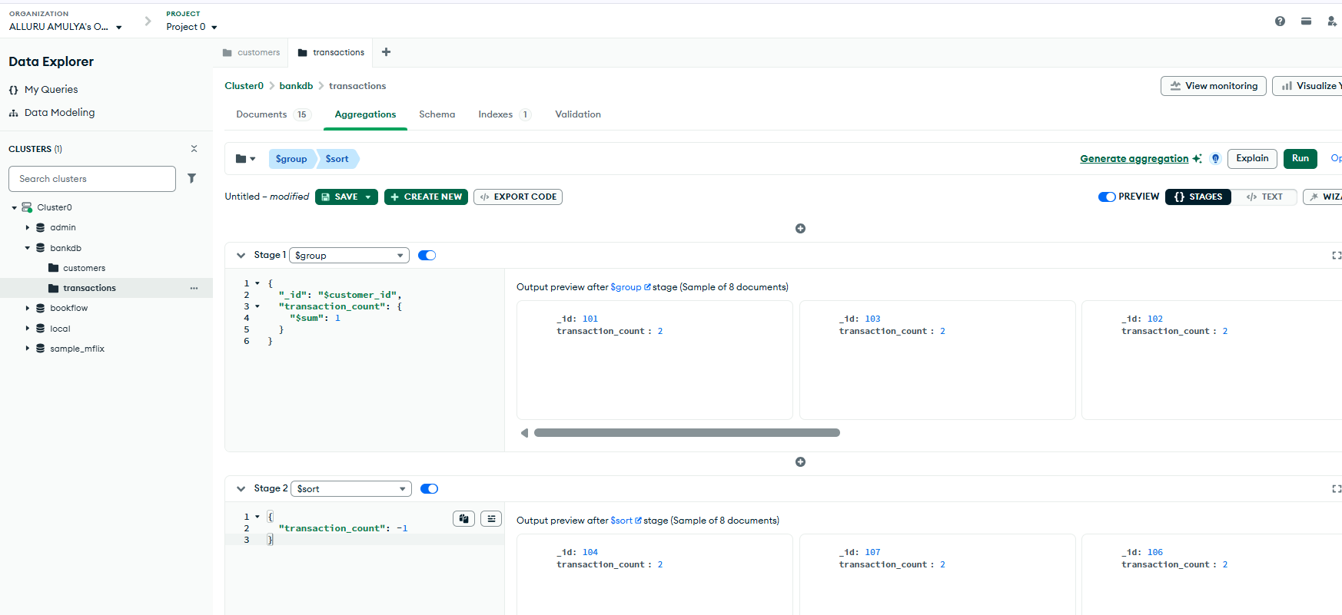

QUERY 17: CUSTOMER + TRANSACTION JOIN
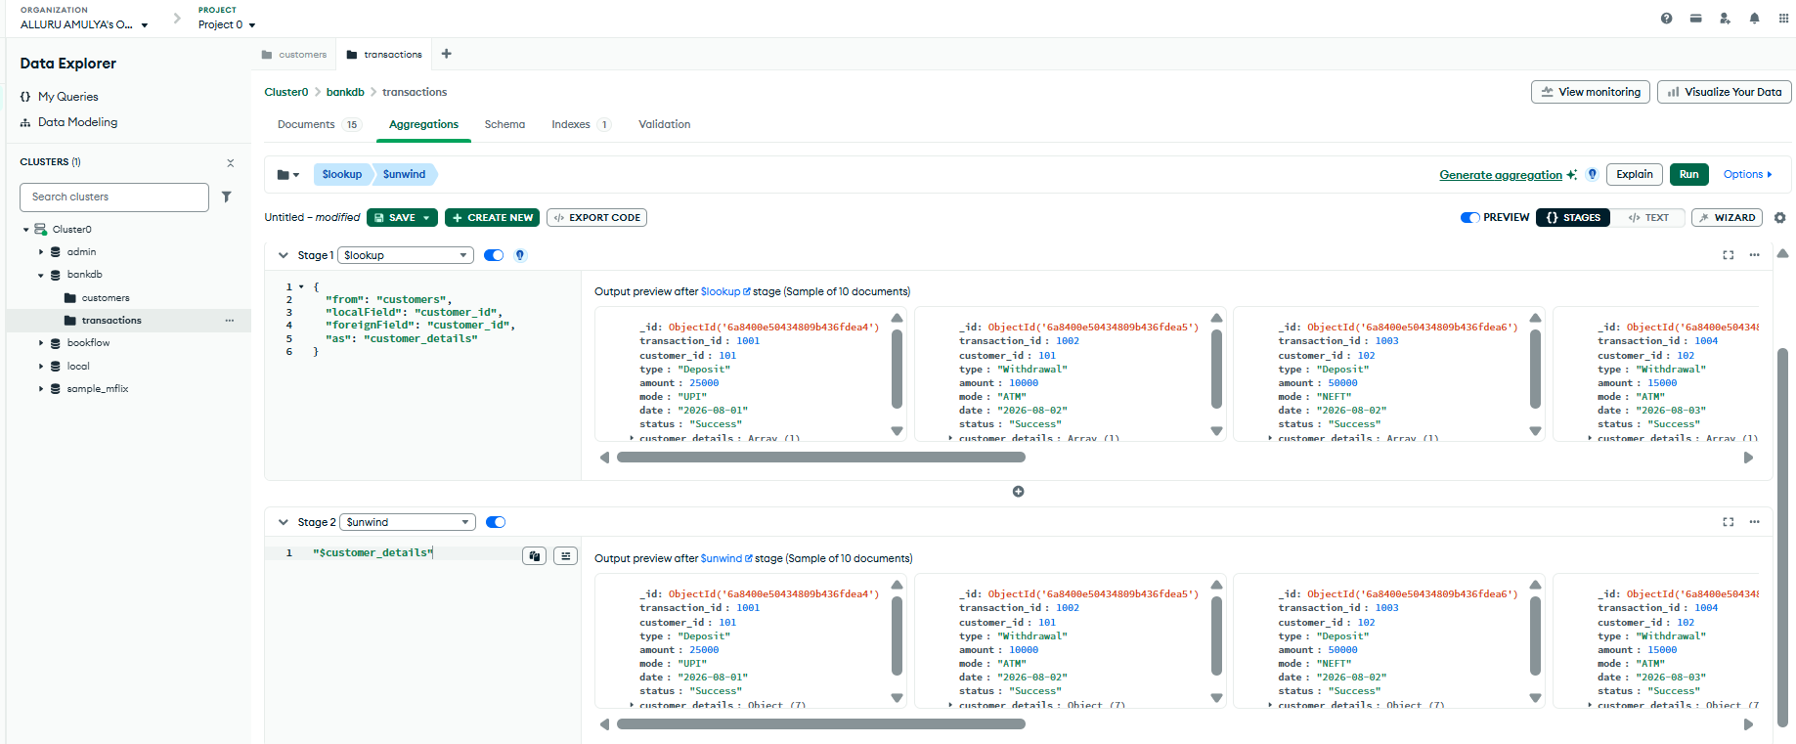

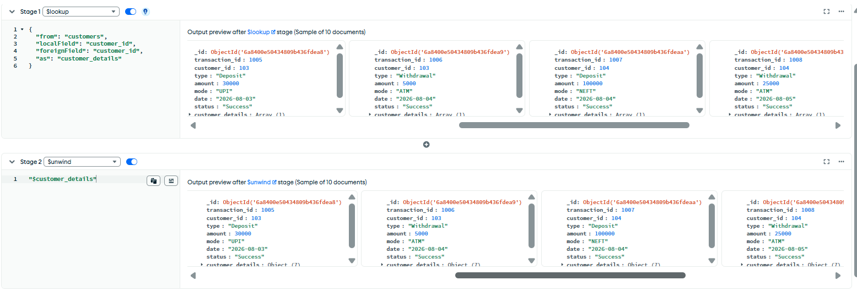
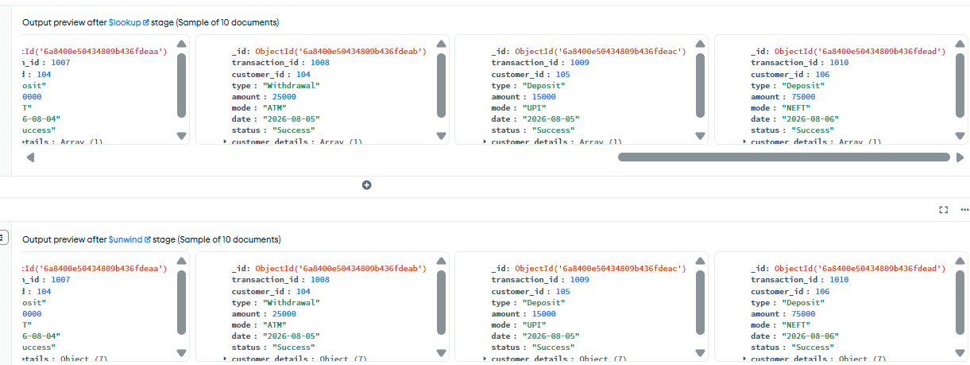

QUERY 18: DISPLAY CUSTOMER NAME AND TRANSACTION AMOUNT
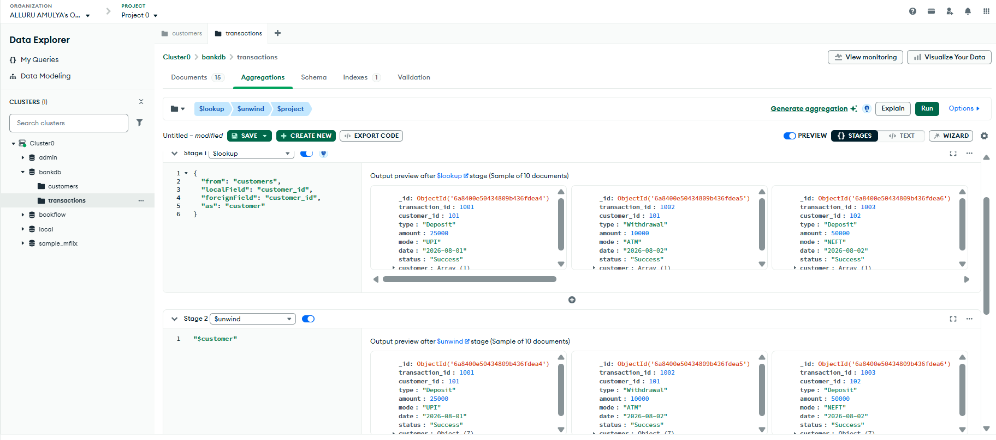
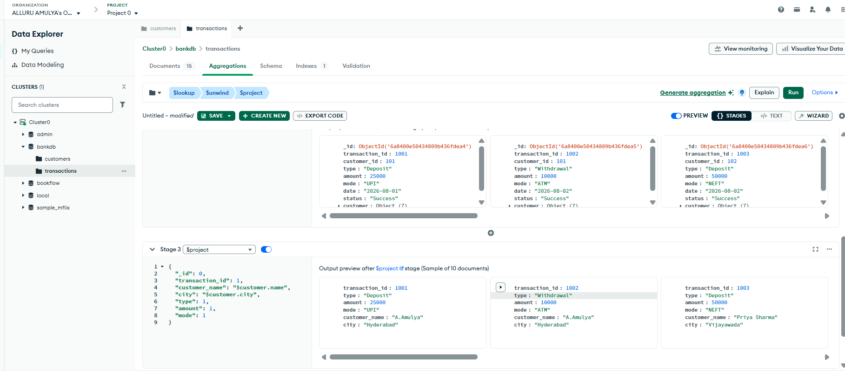

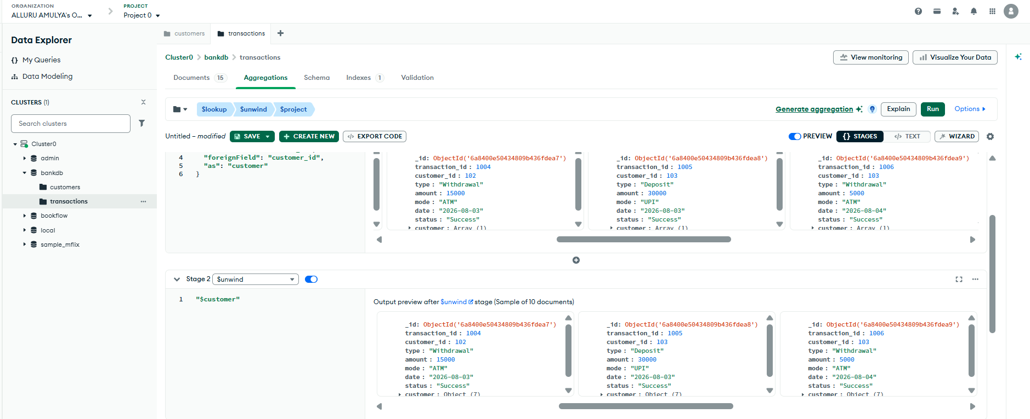

QUERY 19: TOTAL TRANSACTION AMOUNT FOR EACH CUSTOMER
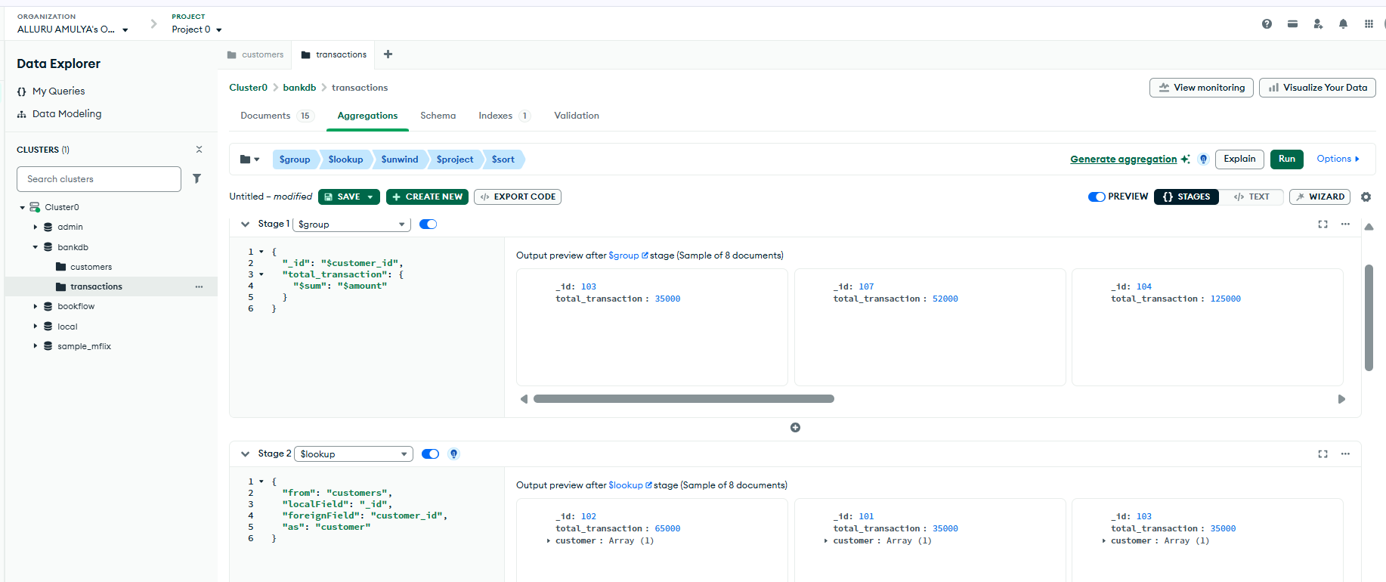
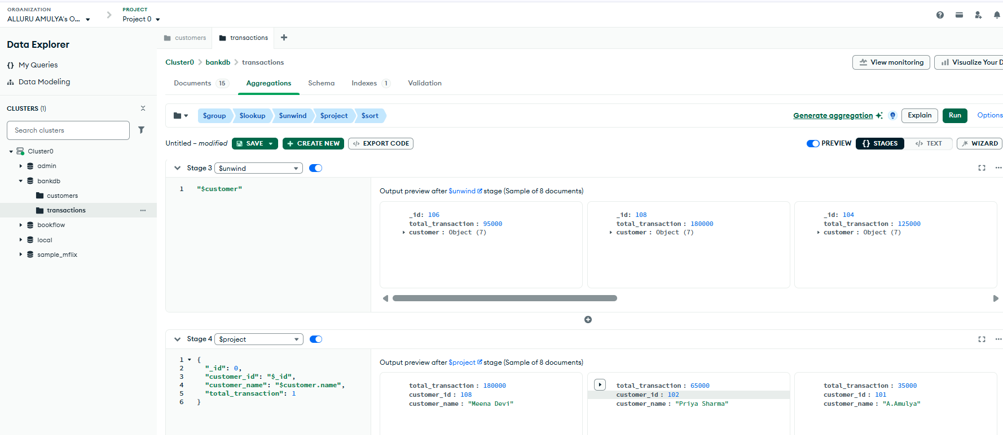
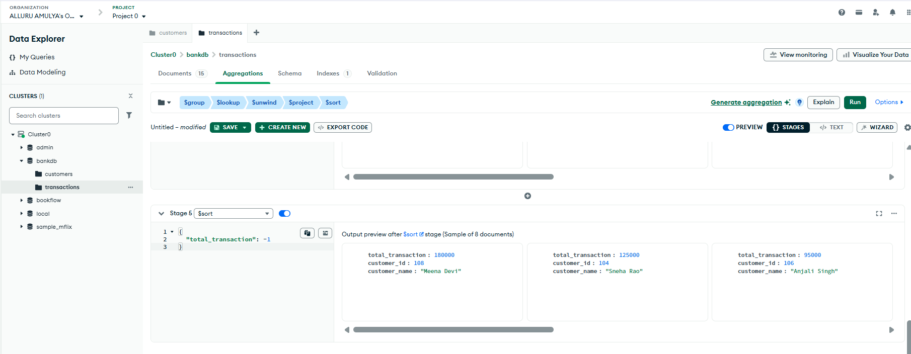
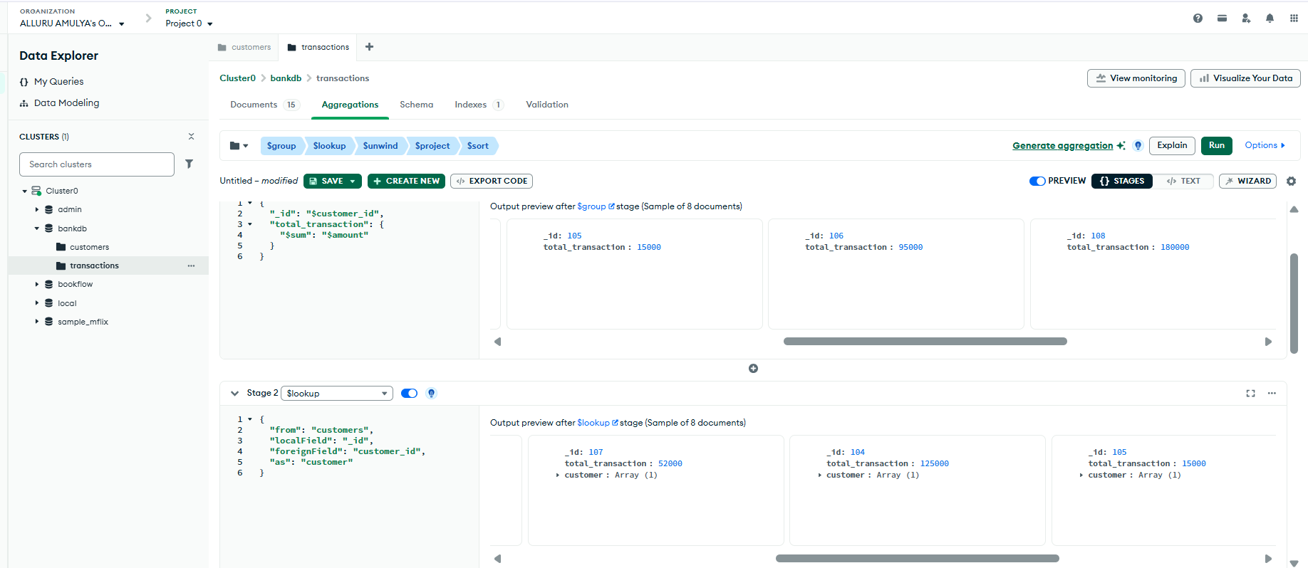
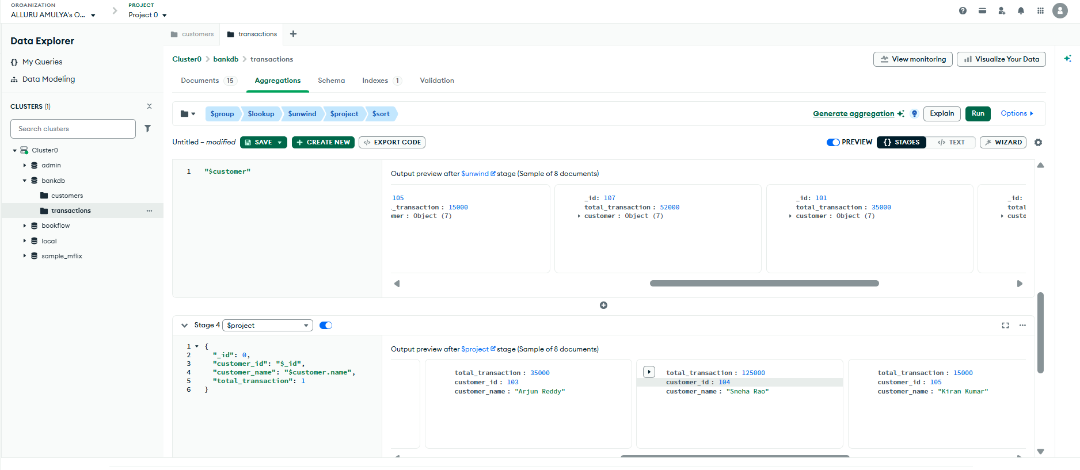
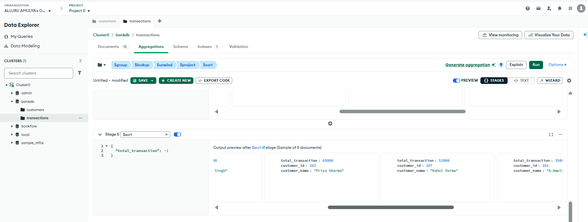

QUERY 20: COMPLEX BANK TRANSACTION REPORT
